Fractions

Adding or Subtracting Unlike Fractions
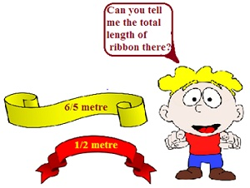
Addition of Unlike Fractions
- These fractions have different denominators.
- Firstly, the fractions are converted into equivalent fractions with a common denominator.
- To do so, the LCM of denominators is calculated.
- The fractions are converted into like fractions with a common denominator.
- The common denominator is retained
- The numerators are added.
Subtraction of Unlike Fractions
- These fractions have different denominators.
- Firstly, the fractions are converted into equivalent fractions with a common denominator.
- To do so, the LCM of denominators is calculated.
- The fractions are converted into like fractions with a common denominator.
- The common denominator is retained
- The numerators are subtracted.

Problem: Solve 2/3 + 1/7
Solution:
These fractions have different denominators.
Firstly, the fractions are converted into equivalent fractions with a common denominator.
To do so, the LCM of denominators is calculated.
So, the fractions are :
= 2*7/3*7 and 1*3/7*3
= 14/21 and 3/21
Adding the numerators we get :
= 14+3/21
= 17/21
So, the answer is 17/21.

Problem: A piece of wire 7/8 metre long broke into two pieces. One piece was ¼ metre long. How long is the other piece?
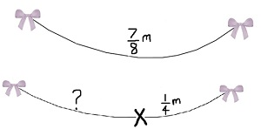
Solution:
Total length of the wire = 7/8 metre
Length of one piece of the wire = ¼ metre
Length of the remaining piece of the wire = 7/8 – ¼
Since these are unlike fractions, they are converted into equivalent fractions with common denominator.
The LCM of 8 and 4 is 8. 7/8 already has the denominator of the value 8. ¼ can be converted into 2/8 by multiplying both the numerator and denominator by 2.
Now, we get :
7/8 – ¼
= 7/8 – 2/8
= (7-2)/8
=5/8 metre
Hence the length of the remaining piece of wire is 5/8 metre

